**How to Upload Yaml file in Github:**

Step1: Click this link for GitHub [Sign in to Genuine Parts Company-EMU (github.com)](https://github.com/enterprises/genuine-parts-company-emu/sso)

Step2: Select “Enterprise-data-platform-gpc”[EDP]

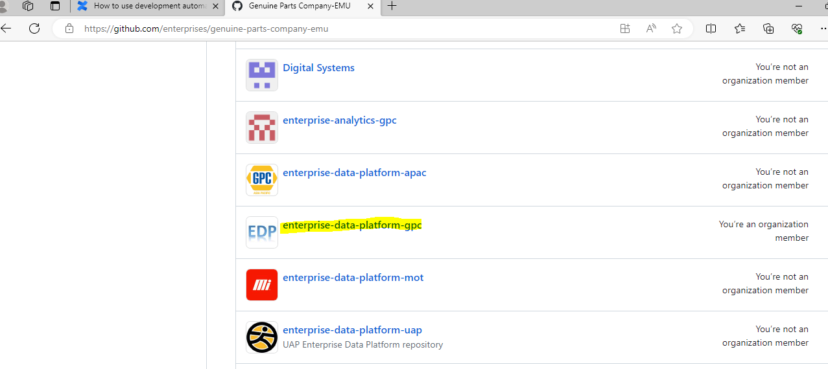

Step3: Select “DEVELOPMENT” repository

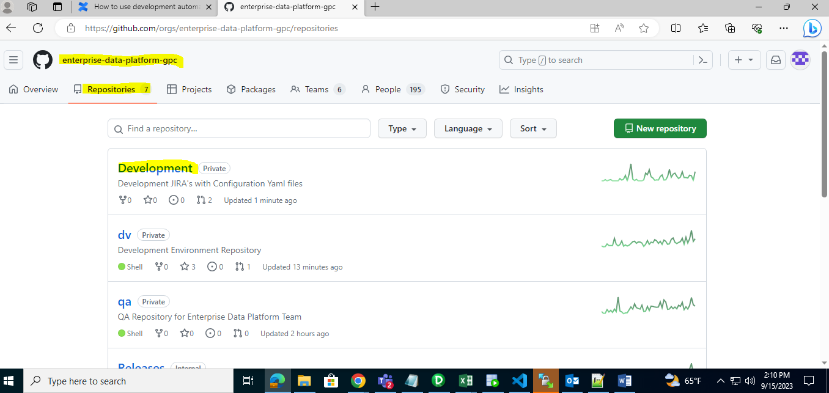

Step4: Go to “Add file”🡪create new file

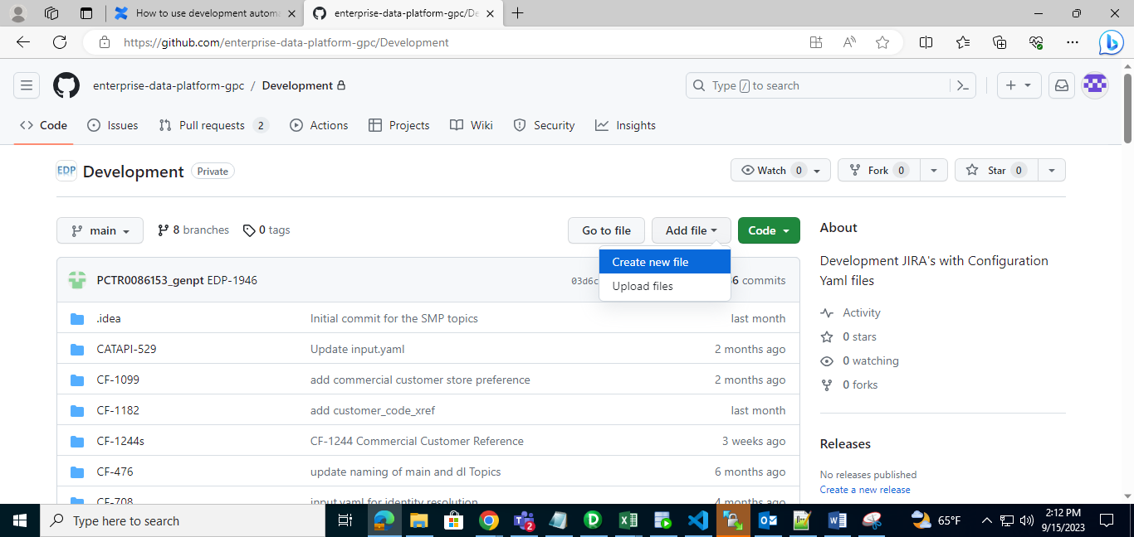

Step5: Give folder name as JIRA number eg:EDP-2425/ , after that give file name “.gitkeep” and select Commit changes

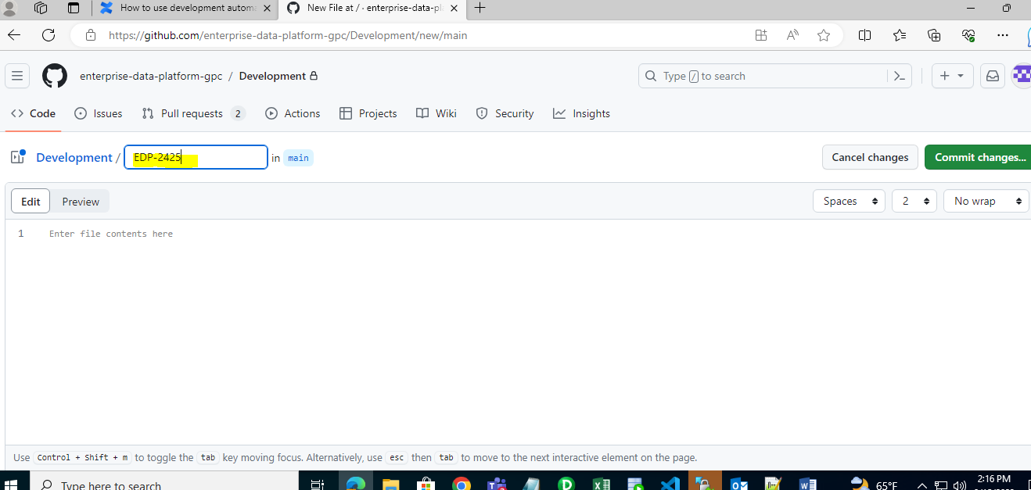

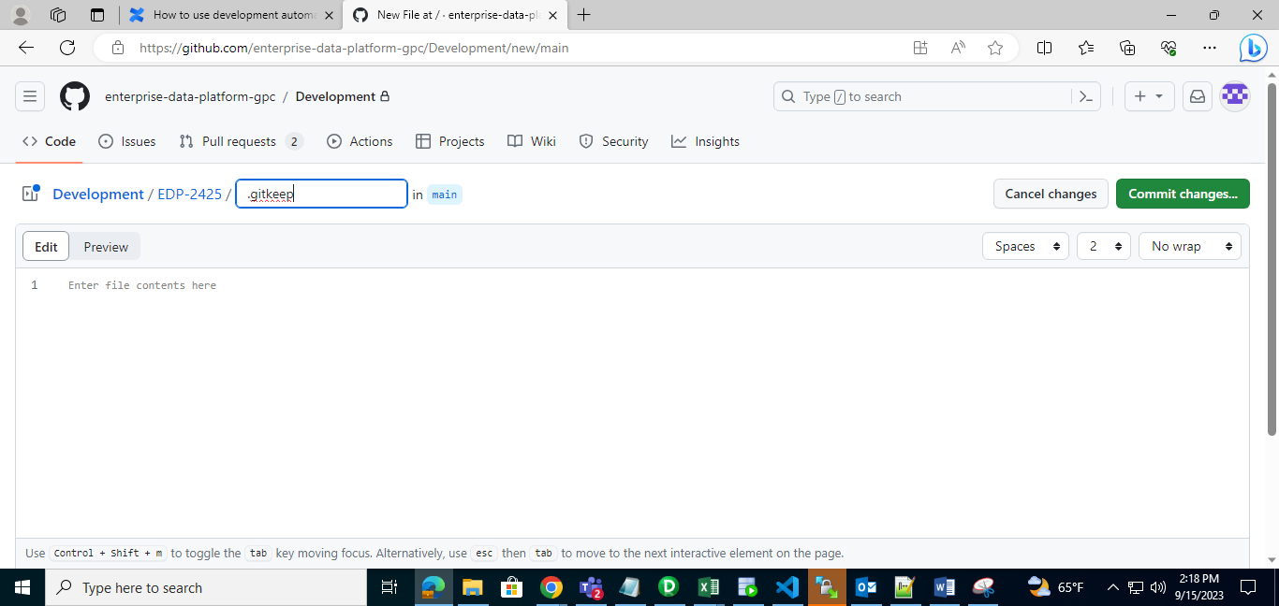

Step6: After Selecting “commit changes”, Popup box appear in that always enter commit message or it will take automatically 🡪 then click “Commit changes button”

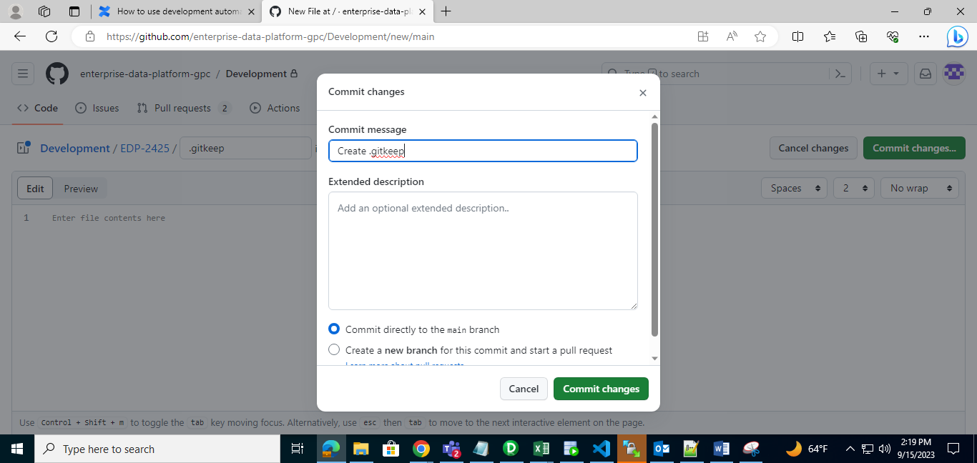

Step7: Go back to “DEVELOPMENT “ respository.

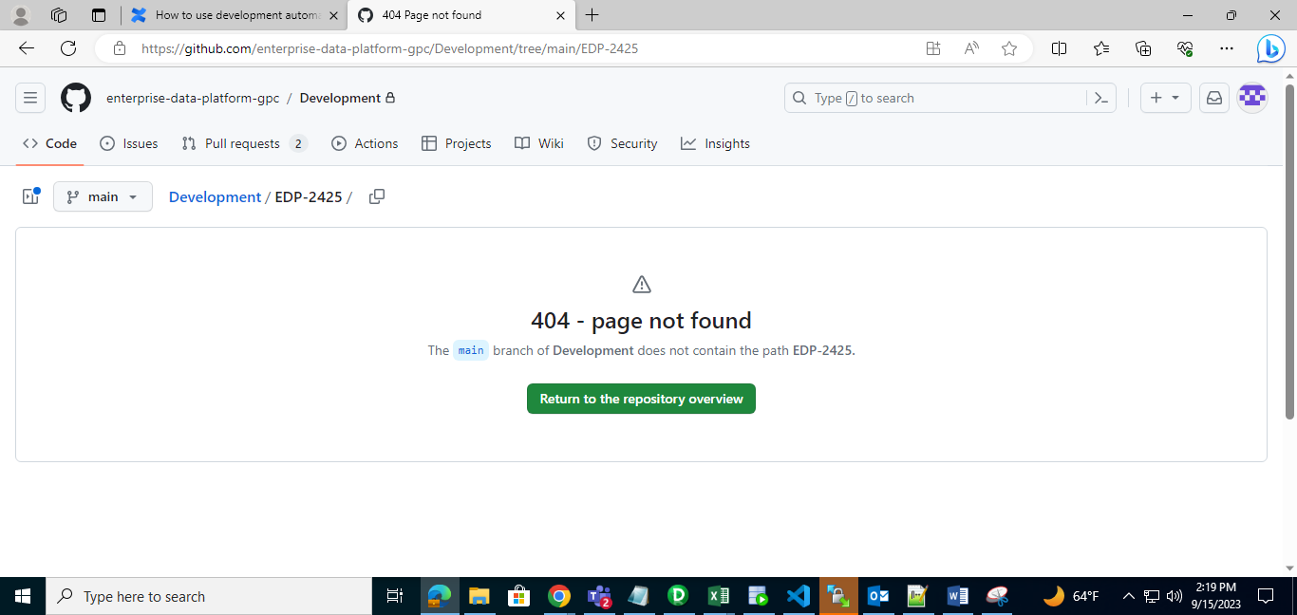

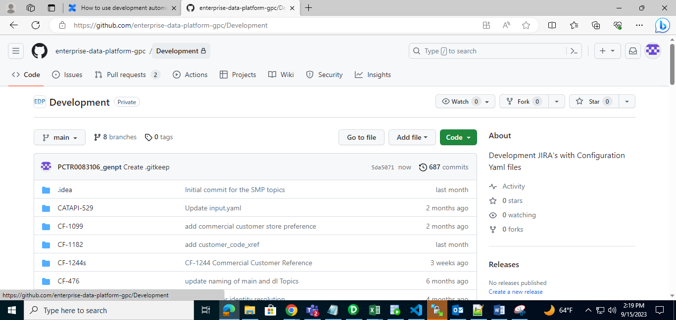

Step8: We can see the folder which we created [EDP-2425]. Select that folder

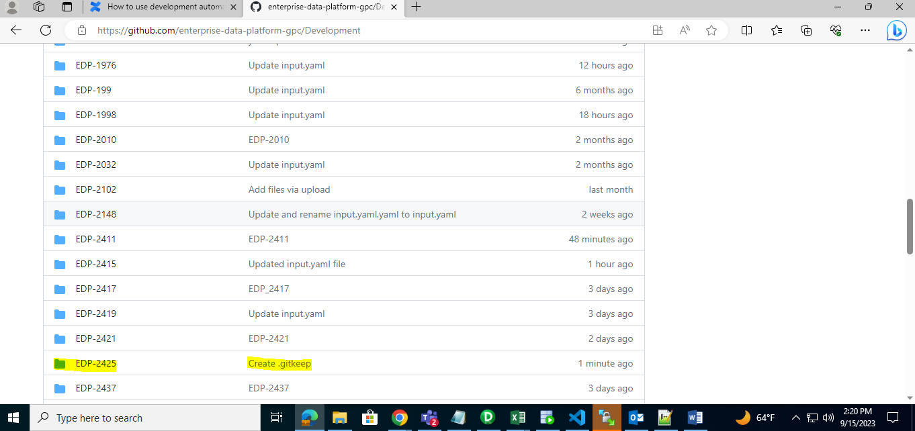

Step9: After selecting that folder, we can see our file was placed “.gitkeep”. Select Add file🡪choose upload file

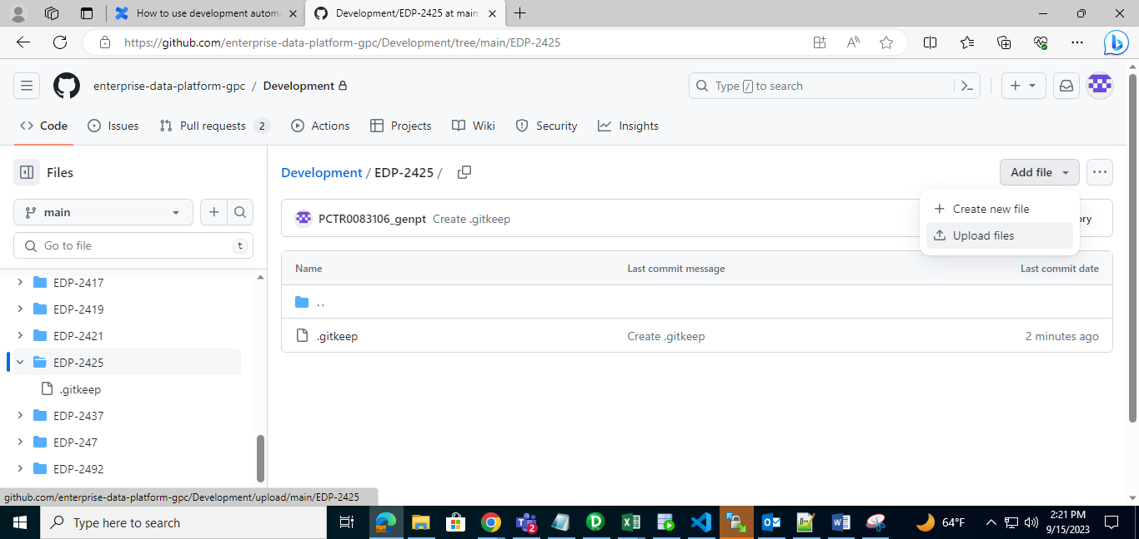

Step10: Click “Choose your file”🡪select your Yaml file from local system upload to here

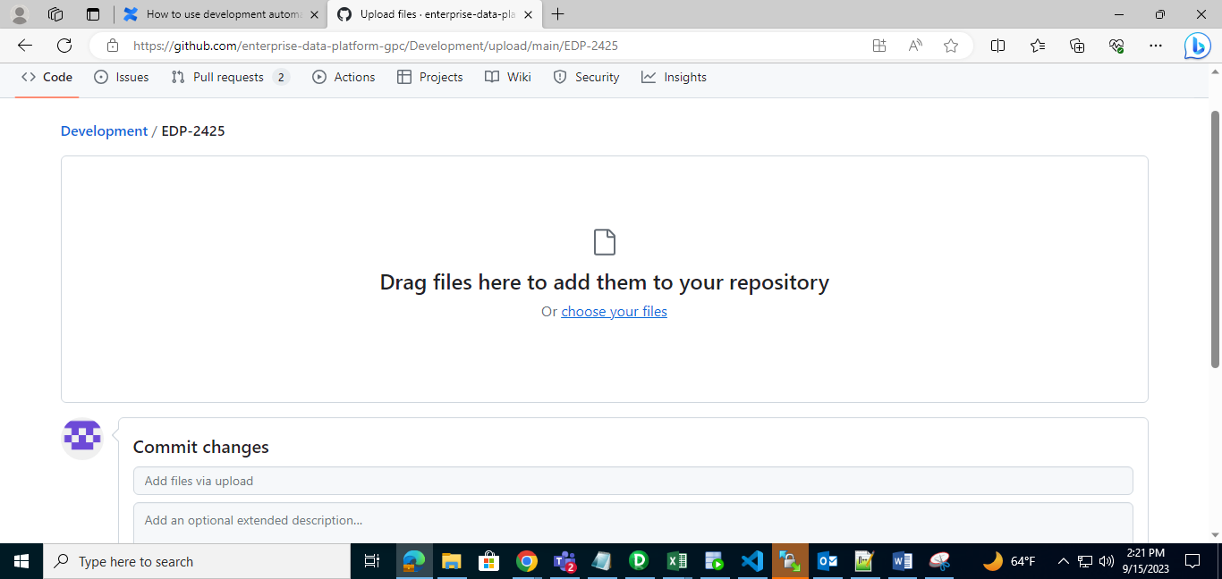

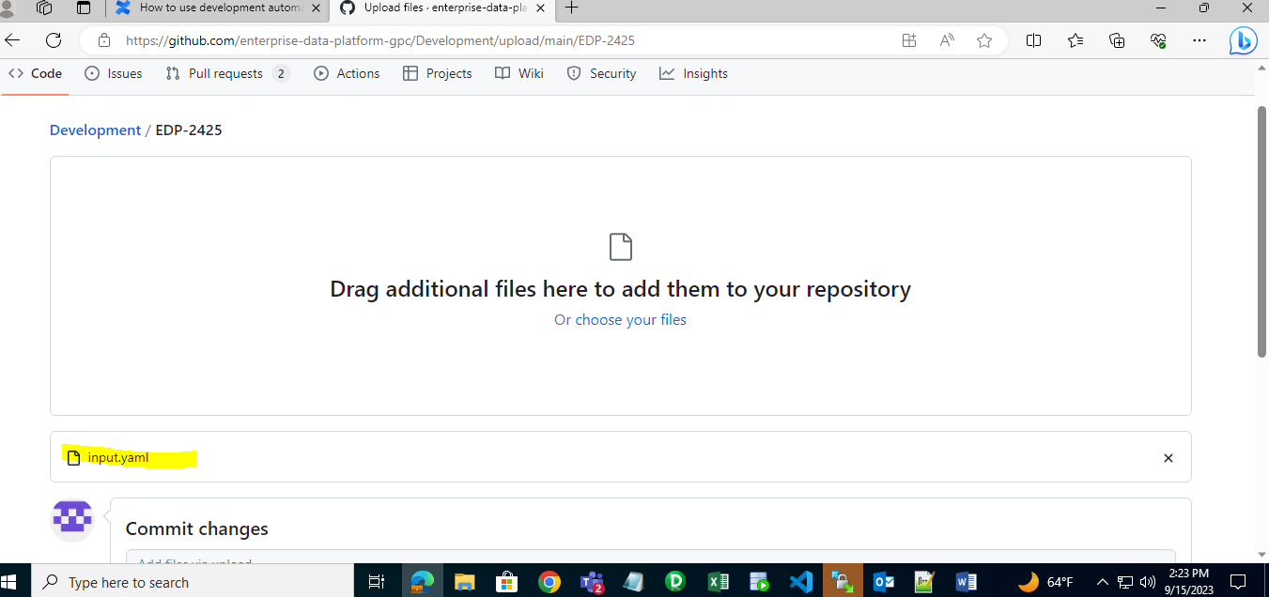

Step11: After uploading a input.yaml file, leave some commit message eg:[EDP-2425]

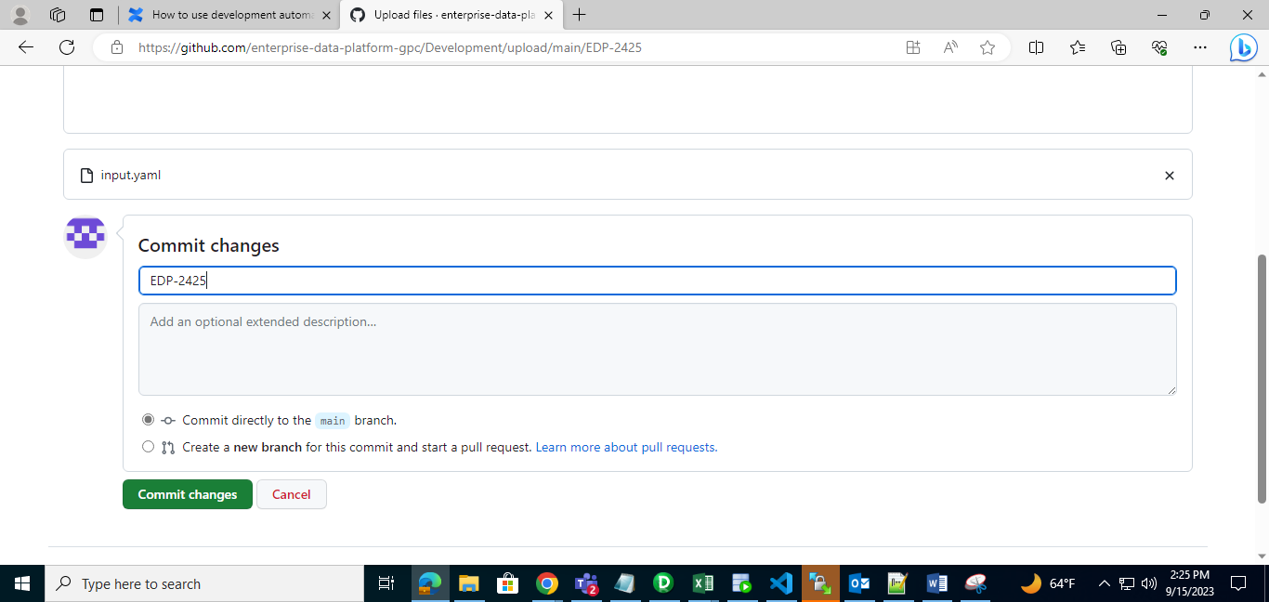

Step12: Check in Development repository 🡪 go to your folder[EDP-2425]🡪 check yaml file is upload or not

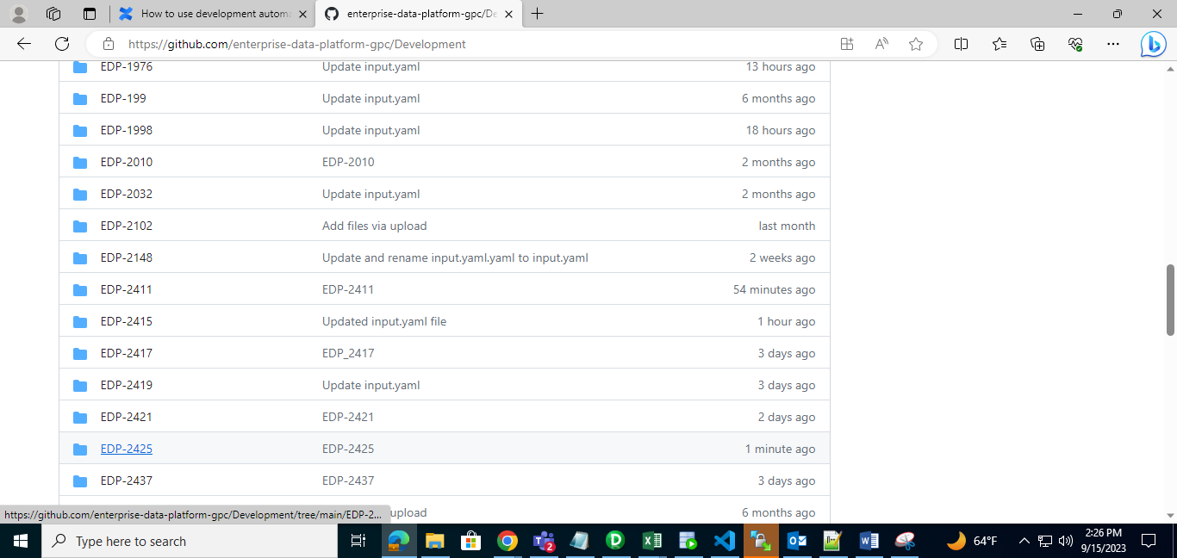

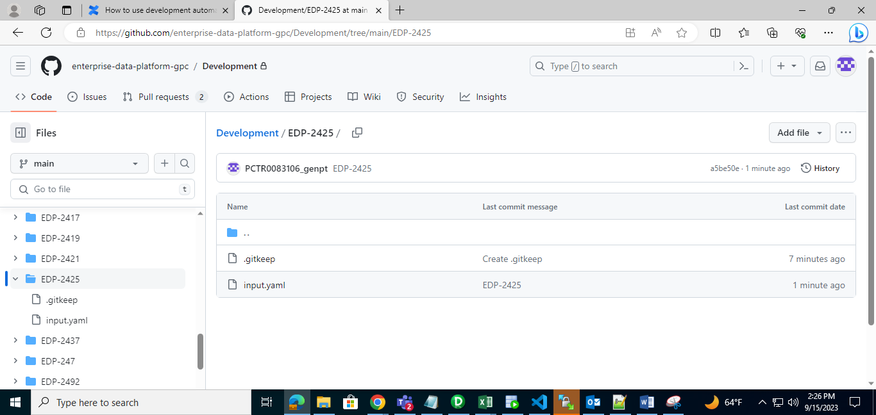

Note: Step1- Step12 🡪How to upload Yaml file in Development respository

**How to Execute Yaml file in Github:**

Step13: Go to EDP🡪 select “DEVELOPMENT AUTOMATION” repository

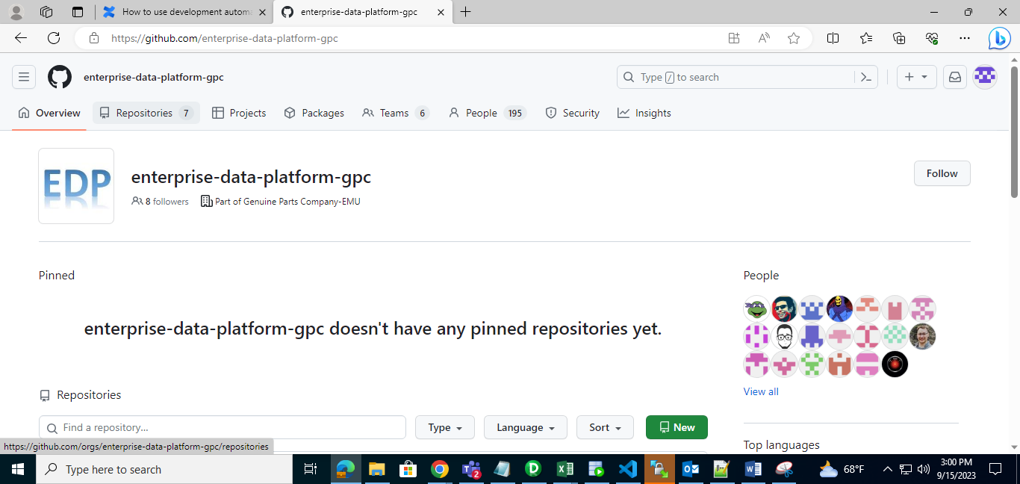

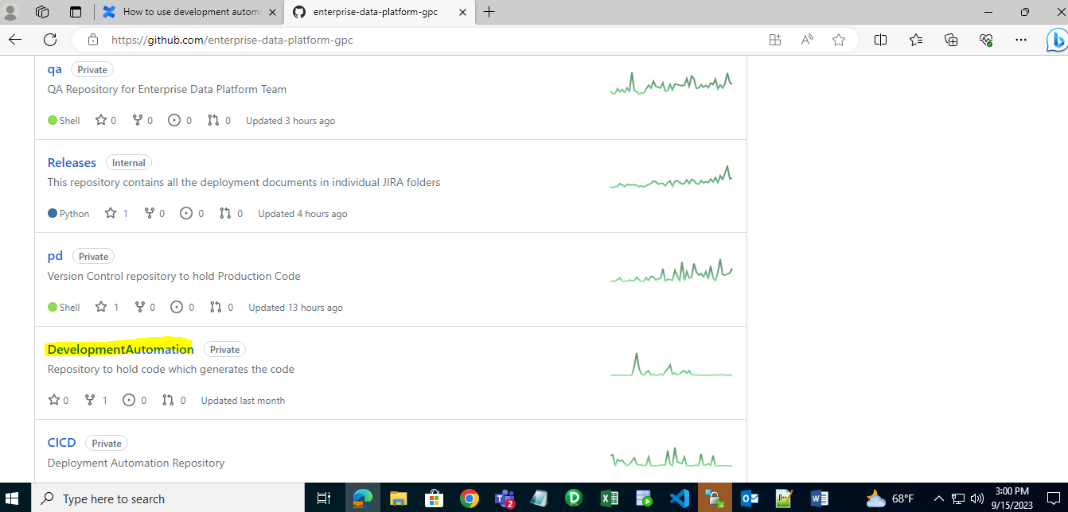

Step14: Go to “Actions”🡪”Ingestion_Automation”🡪Run_workflow🡪Give Jira number [EDP-2425]🡪Click “Run Workflow” button

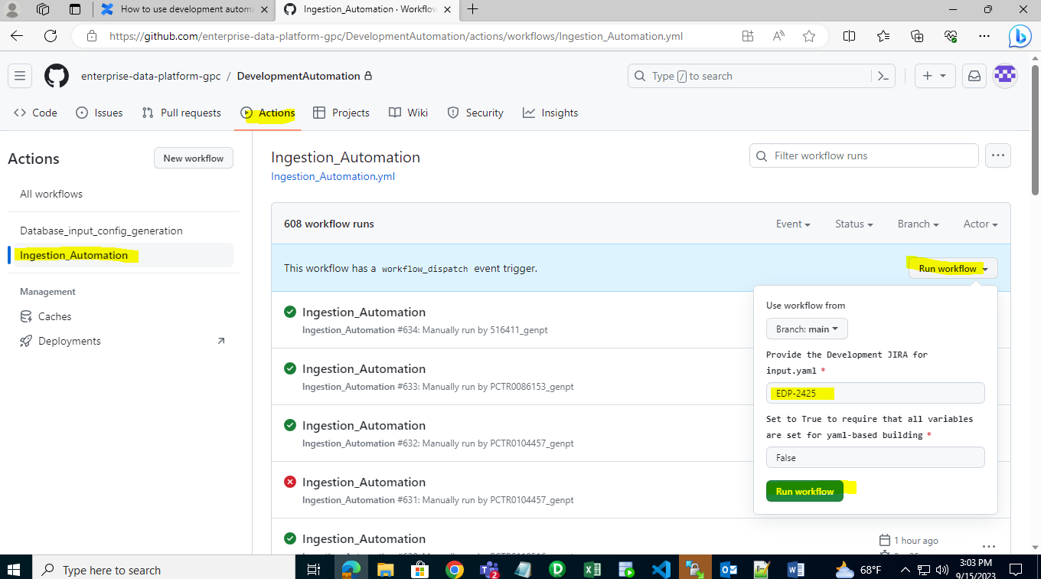

Step15: Click Ingestion_Automation

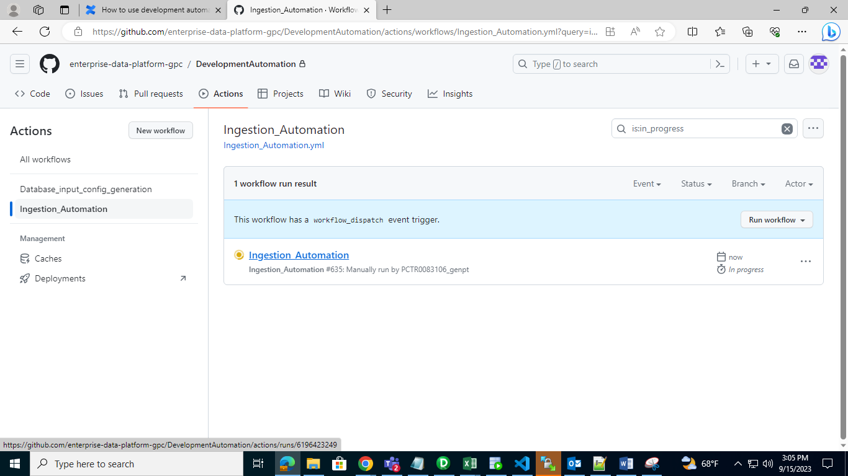

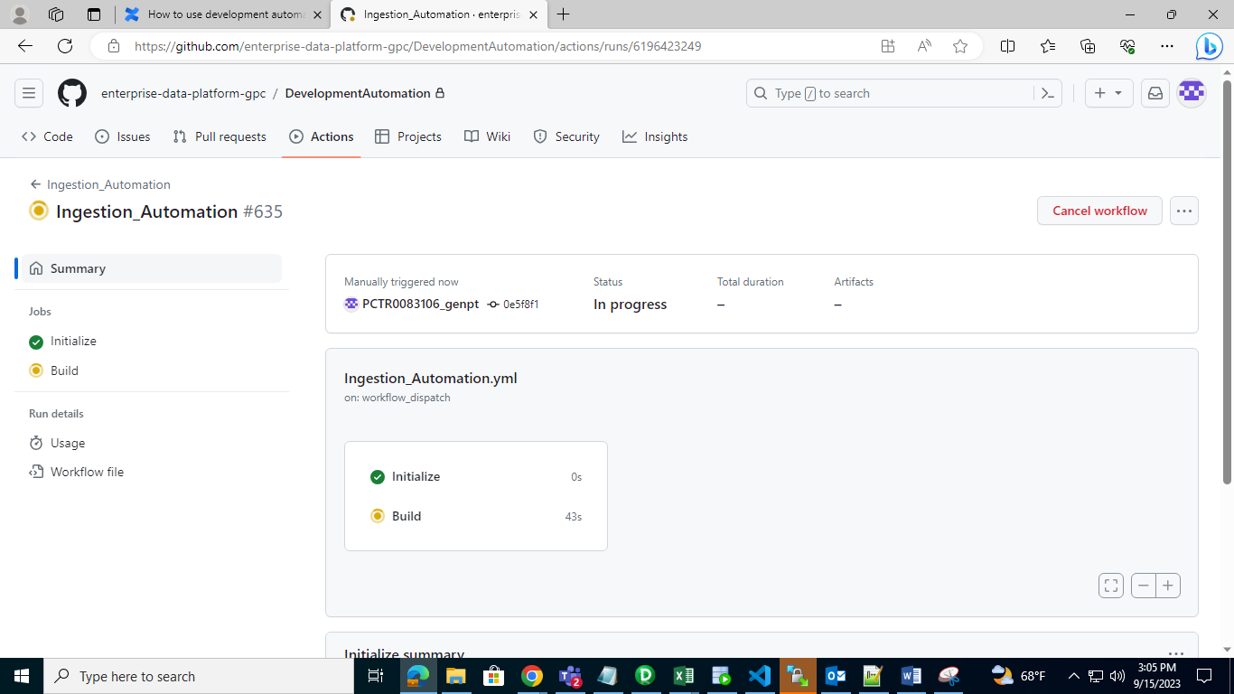

Step16:By this process, It will create Buckets,DDL,DML,param file.After Succesfully execution it will clone to “dv” respository folder.

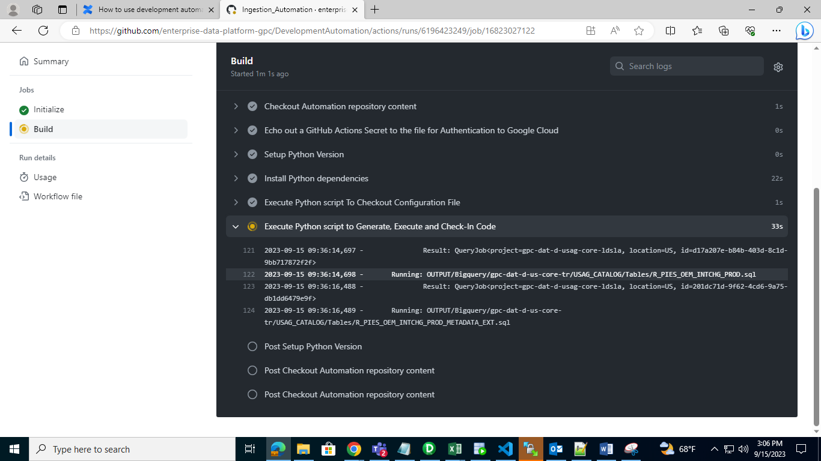

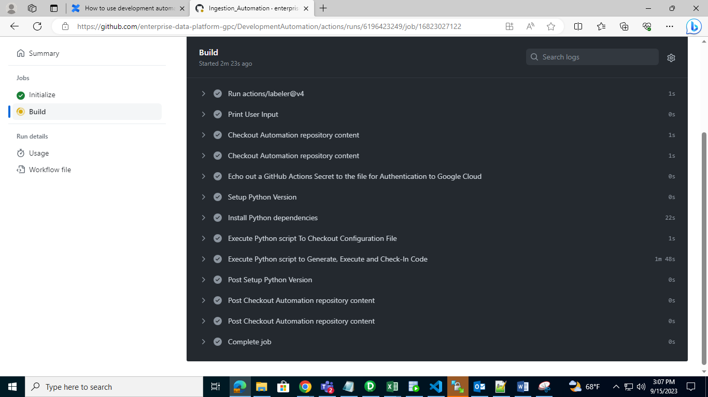

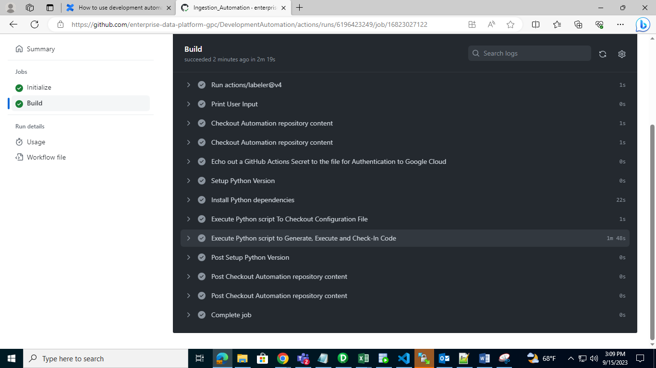

Step 17: Select EDP🡪Go to ‘dv’ respository🡪here we can see all Buckets,DDL,DML,param file

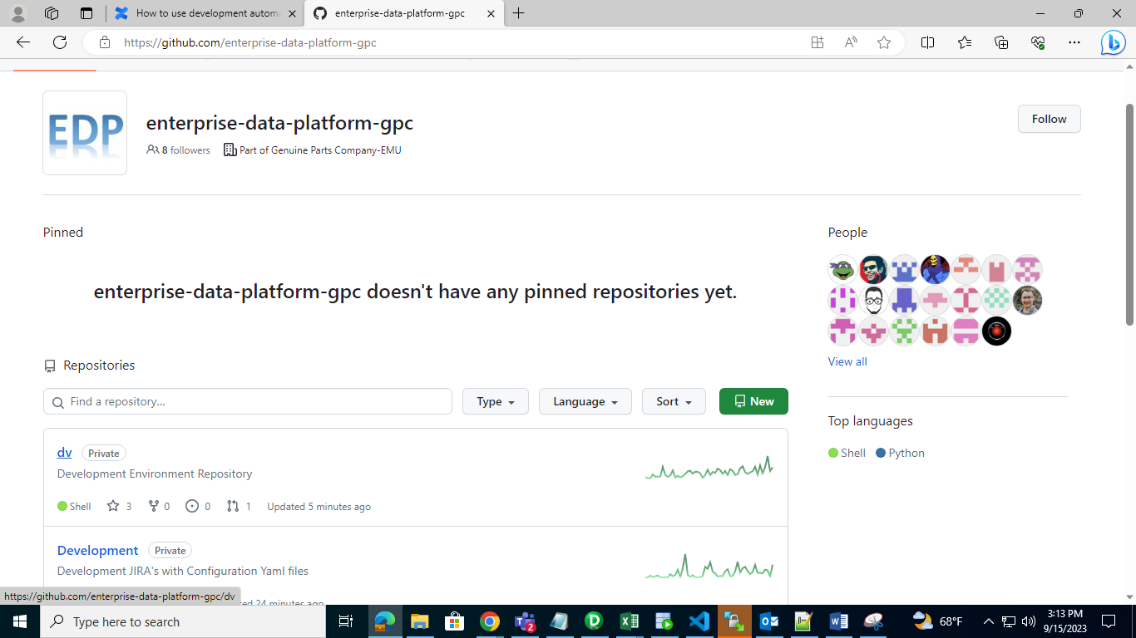

Step 18: To find your DML go for this path

**dv/Bigquery/gpc-dat-d-us-core-tr/LOAD_UTILITY/Scripts**

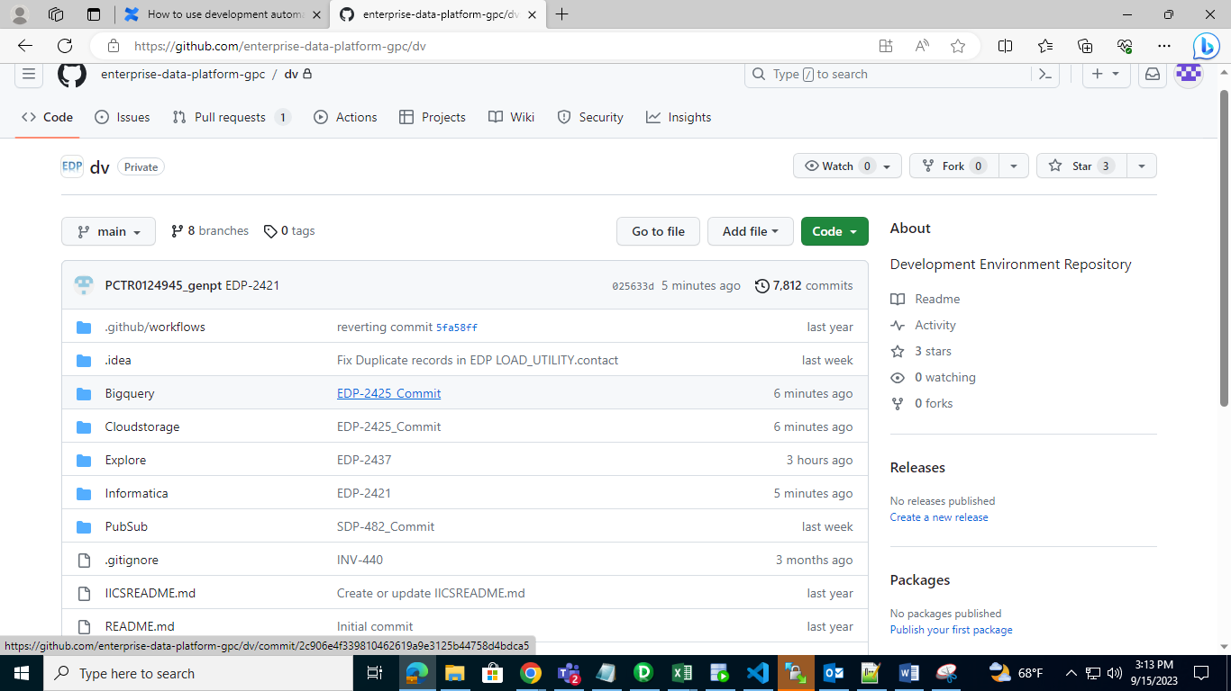

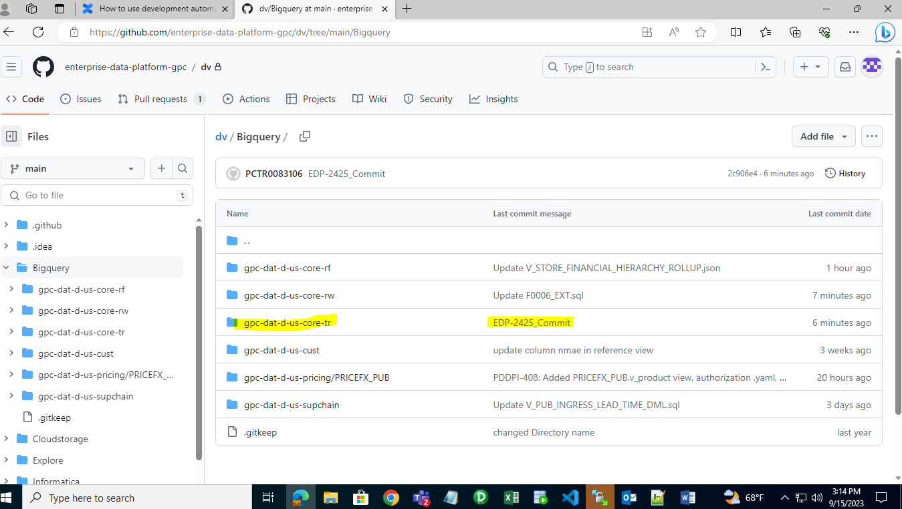

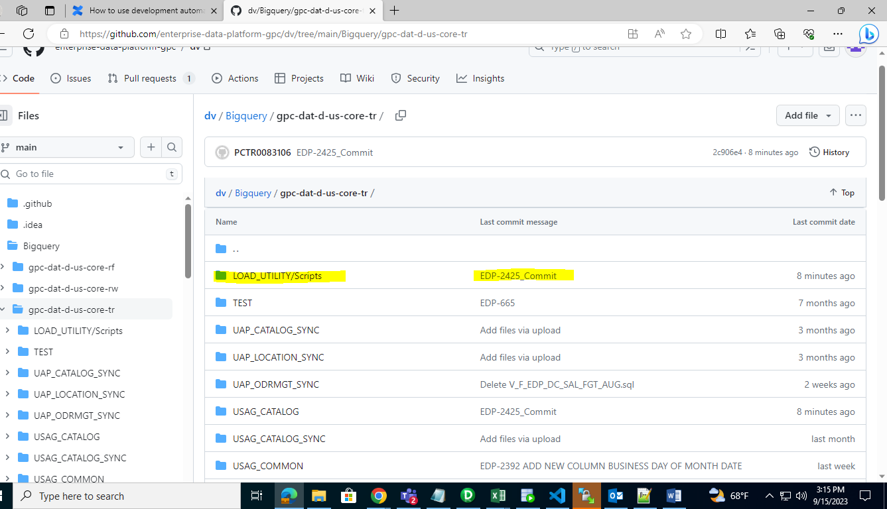

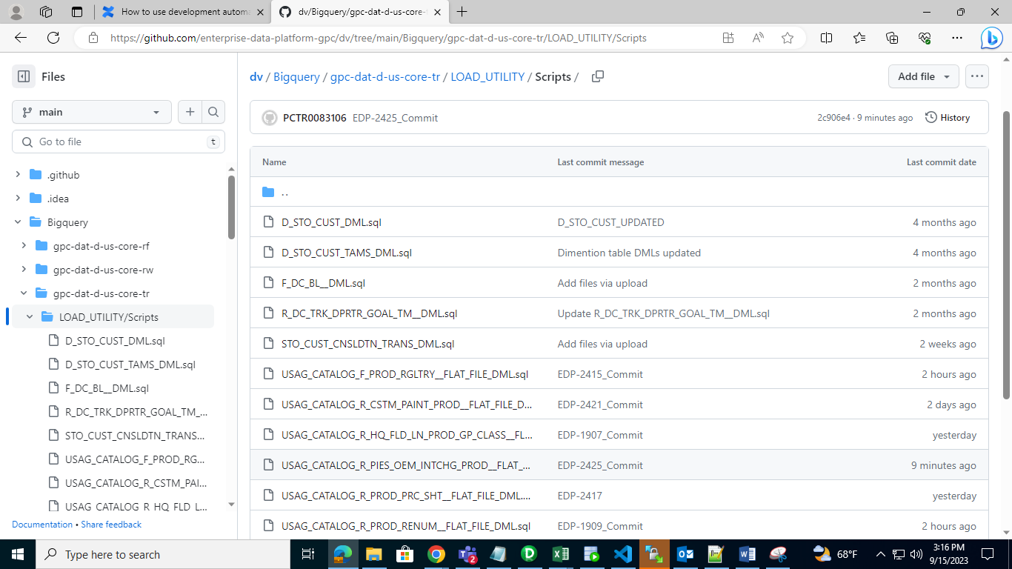

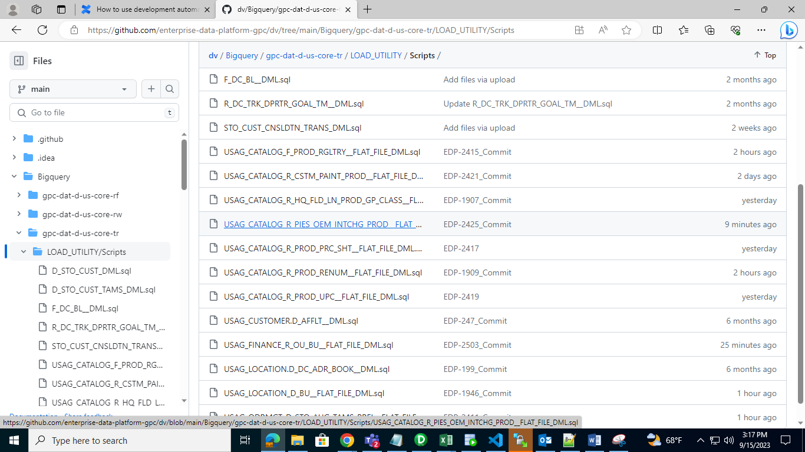

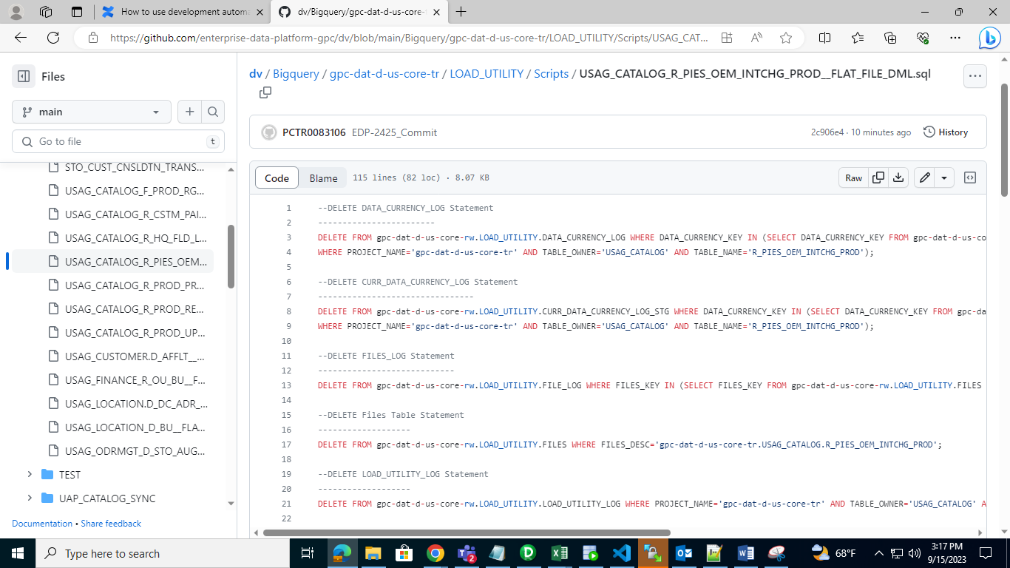

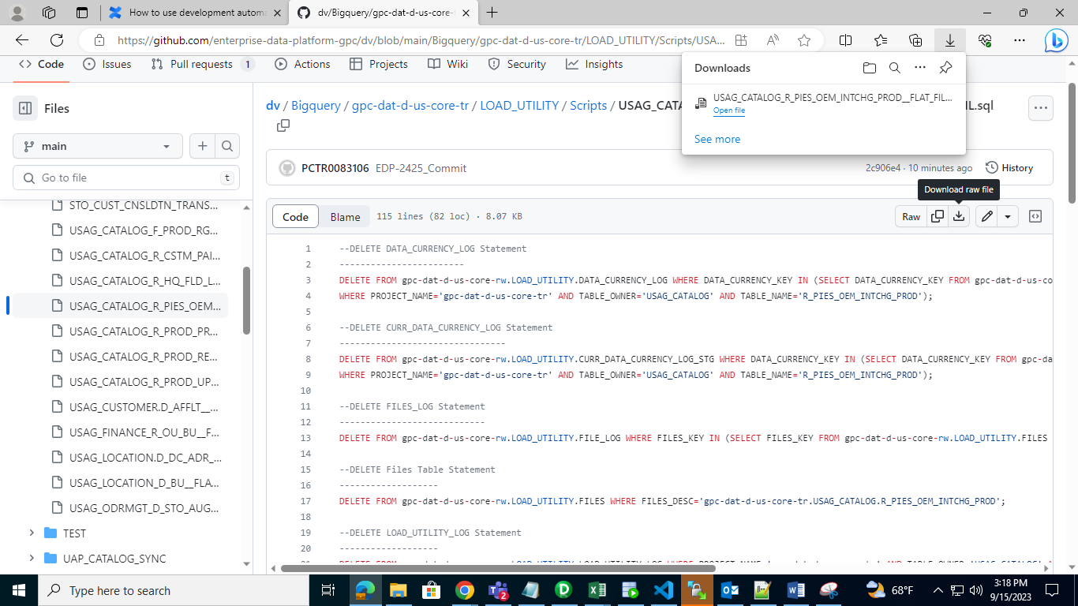

Step19: To find Param file 🡪go to this path

**dv/Informatica/BWParam**

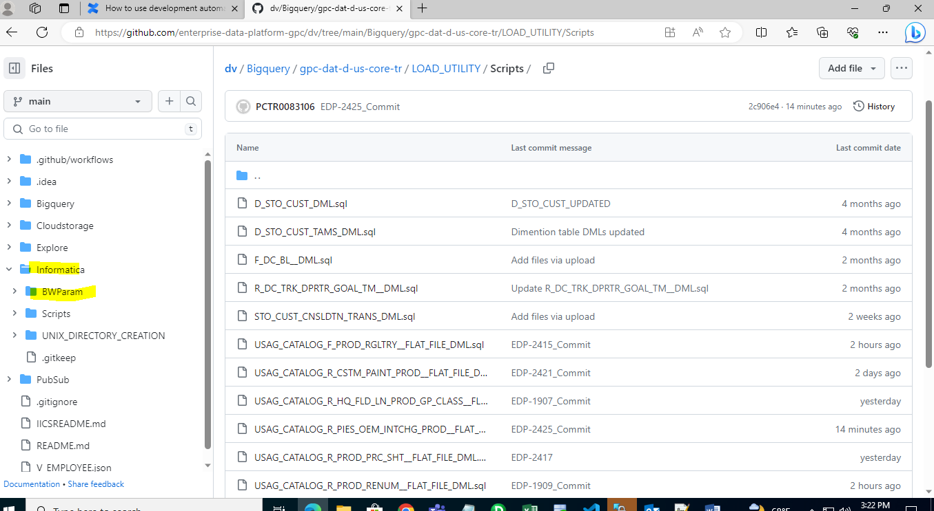

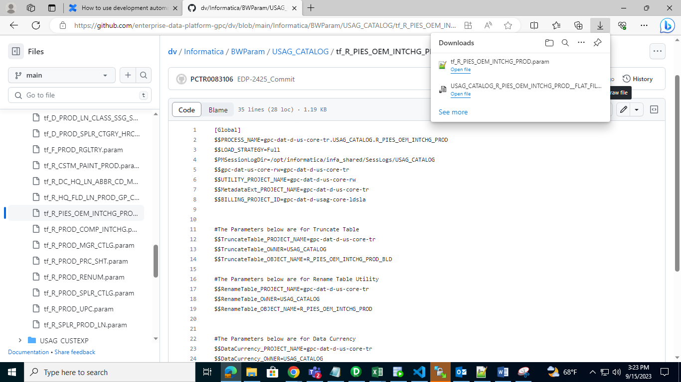

Step20: To find DDL🡪Go to this folder.

**dv/Bigquery/gpc-dat-d-us-core-tr/USG_CATALOG[choose specify folder]/Tables**

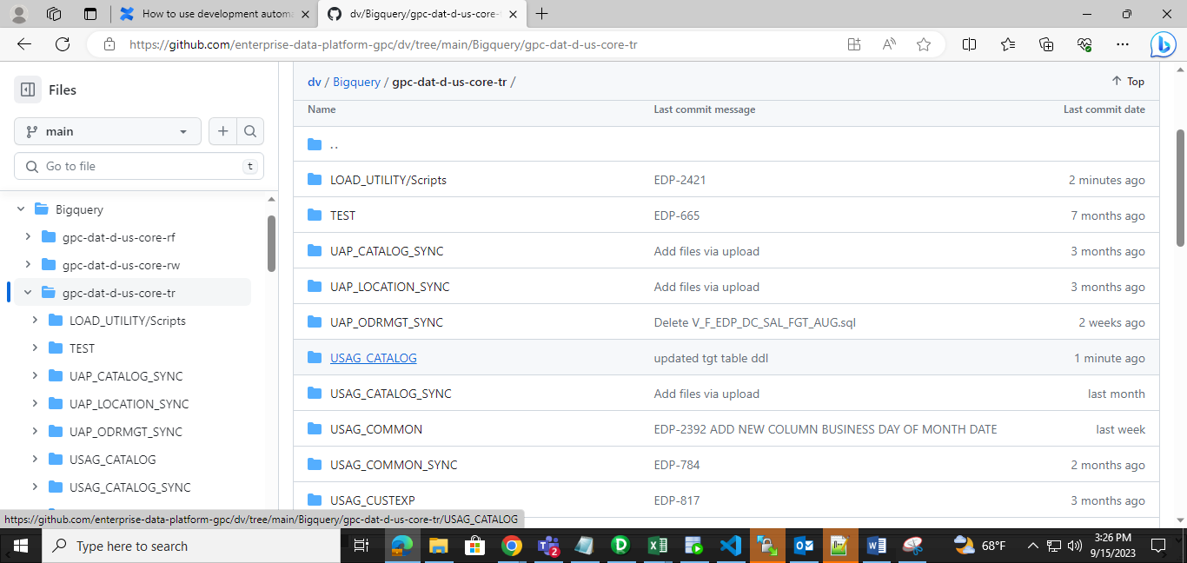

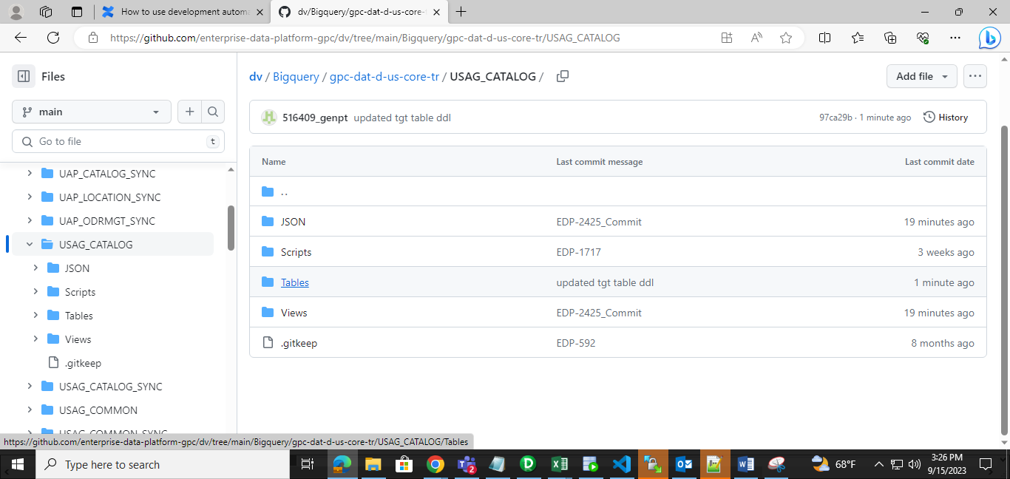

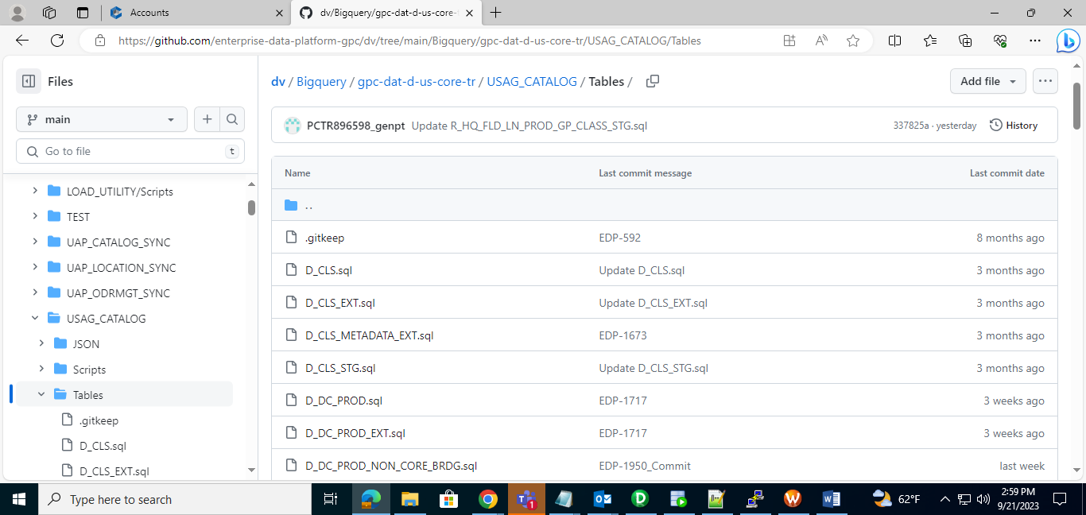

Note: To Update DDL,DML,param file🡪 Either Edit in Github and leave Commit changes or Upload the updated file in Github from your local system and leave Commit changes for that.

